System Monitoring in Linux

**Part 1: Basic System Monitoring**

1. **Task:** Use the `top` command to monitor system performance in real-time.

- ‘top’ command is used to see a real-time update of system performance data.
- Tasks : The total number of processes and threads currently running and sleeping.
- CPU usage : It displays the percentage of CPU utilization. The "us" (user) percentage is the time spent by user-level processes. The "sy" (system) percentage is the time spent by the kernel in system-level processes. The "ni" (nice) percentage is for processes with a positive nice value (lower priority). The "id" (idle) percentage is the CPU's idle time. The "wa" (wait) percentage represents time waiting for I/O operations, and "st" (steal) indicates time stolen from a virtual machine.
- Memory usage : It shows the total memory, used memory, free memory, buffers, and cached memory.

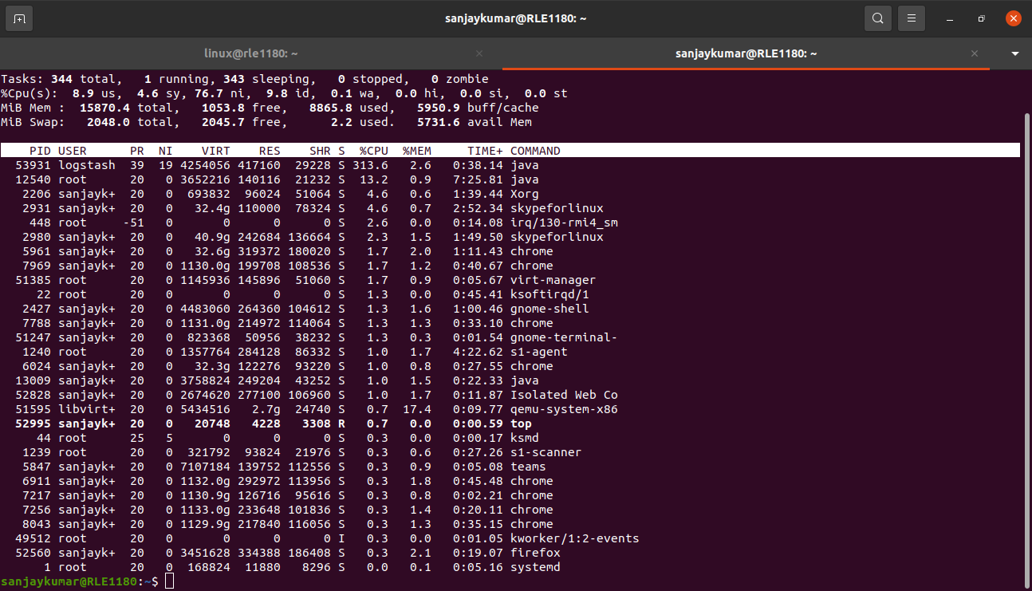
- Top header : load average,number of tasks, and uptime.
- Tasks : total,running,sleeping,stopped and zombie processes.
- CPU : usage percentages for user,system,nice,idle,wait and steal.
- Memory : Total, used, free, buffers, and cached memory.
- Swap : Total, used, free, and available swap space.
- PID : Process ID.
- User : Owner of the process.
- PR : Priority of the process.
- NI : Nice value of the process.
- VIRT : Virtual memory used by the process.
- RES : Resident memory used by the process.
- SHR : Shared memory used by the process.
- S : State of the process (e.g., R for running, S for sleeping).
- %CPU : Percentage of CPU usage by the process.
- %MEM : Percentage of memory usage by the process.
- TIME+ : Total CPU time used by the process.
- Command : the command associated with the process.

2. **Task:** Monitor system resource usage using the `htop` command.

Features and Options

‘htop’ provides an interactive and more user-friendly way to monitor system performance compared to the basic ‘top’ command.

- Colourful interface : ‘htop’ has a colorized and visually appealing interface,making it easier to read and understand.
- Interactive process list : The list of running processes is updated in real-time, and you can interactively scroll through the list and select processes.
- Sortable columns : you can sort processes by different criteria,such as CPU usage,memory usage,or process age,by pressing function keys(F2 to F5).
- Tree view : ‘htop’ provides a tree view that shows the parent-child relationship between processes,making it easier to understand process hierarchies.
- Customizable columns : you can choose which columns to display and even add custom columns to the display.
- Killing processes : easily kill processes by selecting them and pressing the “F9” key.
- Search function : you can search for specific processes by name or PID.
- Detailed process information : ‘htop’ provides detailed information about processes,including the user who started the process,process ID and much more.
- Resource meters : ‘htop’ displays CPU,memory and swap usage in the header,making it easy to monitor resource utilization.

Comparing ‘top’ and ‘htop’

‘htop’ and ‘top’ are the both process monitoring tools,but ‘htop’ offers several advantages over top :

- visual Appeal : ‘htop’ provides a more visually appealing and colorized interface, making it easier to distinguish between different types of processes and resource usage.
- Interactive sorting : ‘htop’ allows interactive sorting of processes by various criteria, while ‘top’ requires complex key combinations to change the sort order.
- Tree view : the tree view in ‘htop’ is useful for visualizing process hierarchies, especially when dealing with multi-threaded or forked processes.
- Killing processes : killing processes is more intuitive in ‘htop’ with the “F9” key,while in ‘top’,you need to remember the PID.
- Customization : ‘htop’ offers more options for customizing the display,including which columns are visible.
- Search function : ‘htop’ provides a search function to quickly locate specific processes.

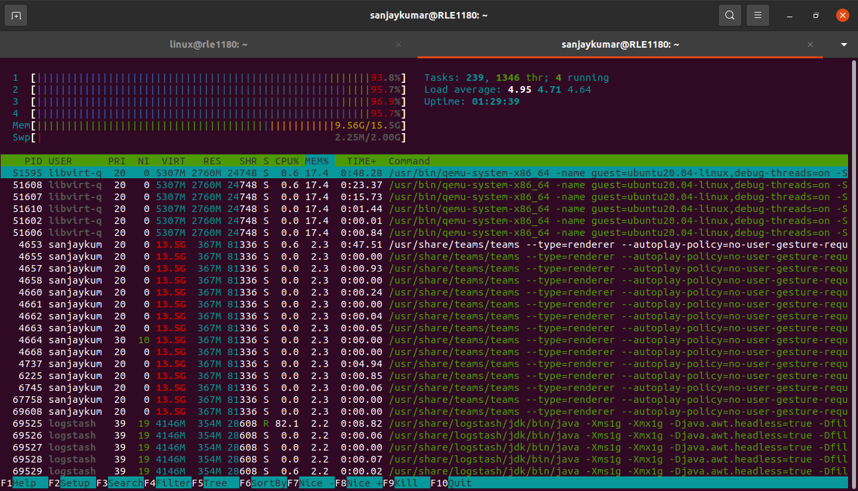

**Part 2: Disk Usage Monitoring**

3. **Task:** Use the `df` and `du` commands to monitor disk space usage.

- ‘df’ command to display information about disk space usgae on your system.
Ex : sudo df -h
‘-h’ option stands for “human-readable”,and it displays sizes in a more understandable format. i.e, GB,MB.
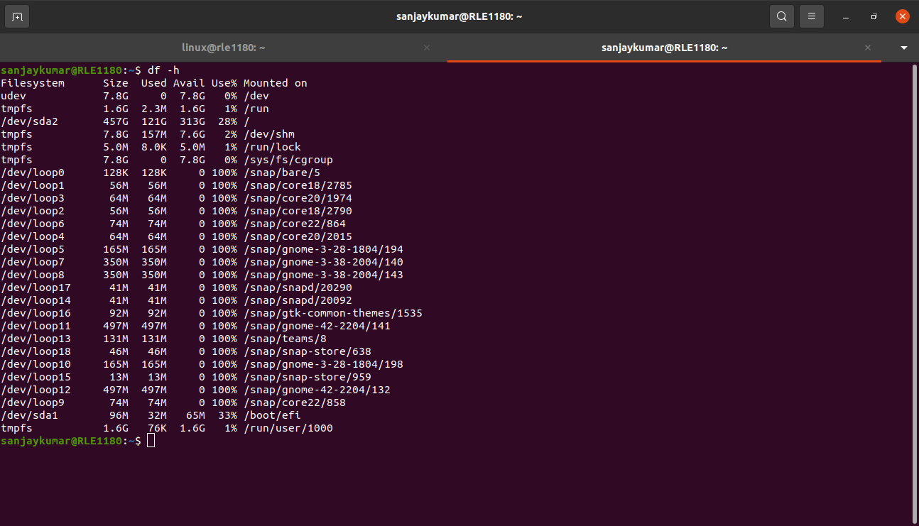

- ‘du’ command used to calculate the size of a specific directory.
Ex : sudo du -sh /home/sanjaykumar
-s : summarize(displays the total size).
-h : human – readbale(formats the size for easier reading).
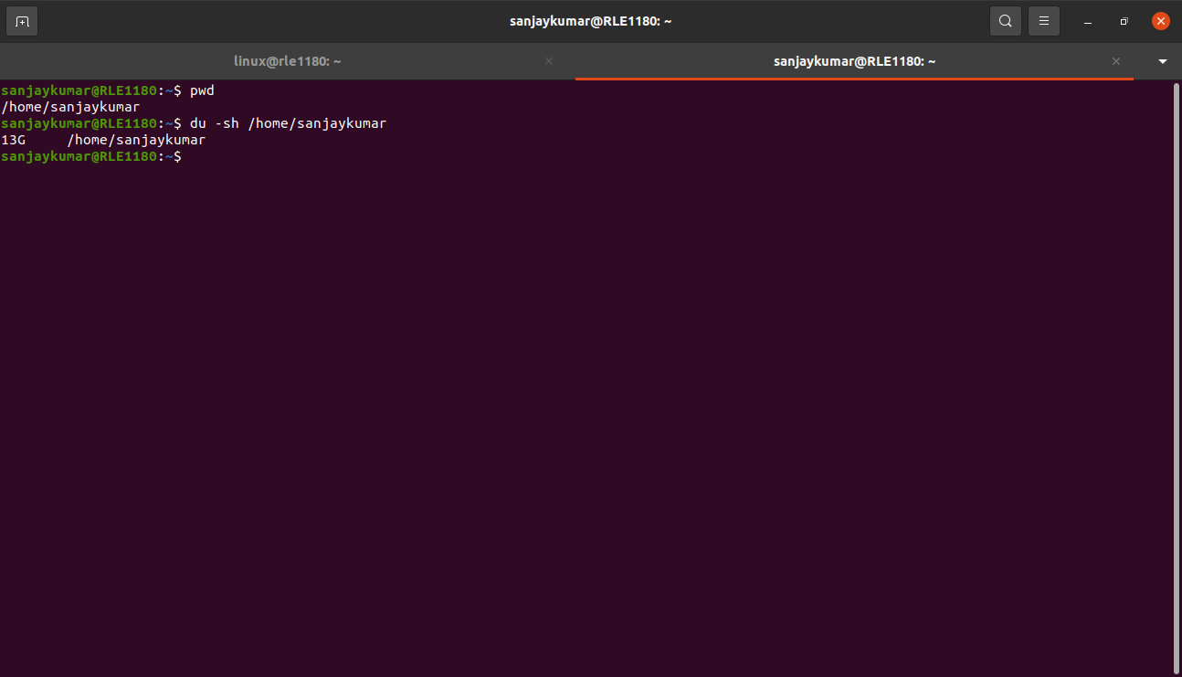
To find and report on the largest directories consuming disk space on your system,you can use a combination of ‘du’ and ‘sort’ commands.

The following command will list the top 10 largest directories under the root directory:
Ex : sudo du -h / 2>/dev/null | sort -rh | head -n 10
- sudo is used to ensure you have the necessary permissions to access all directories.
- 2>/dev/null redirects error messages to /dev/null to prevent premission-denied errors from being displayed.
- Sort -rh sorts the output in reverse order,listing the largest directories first.
- Head -n 10 displays the top 10 largest directories.

This command will provide a list of the largest directories and their respective sizes. You can adjust the number of directories displayed by changing the value in head -n.
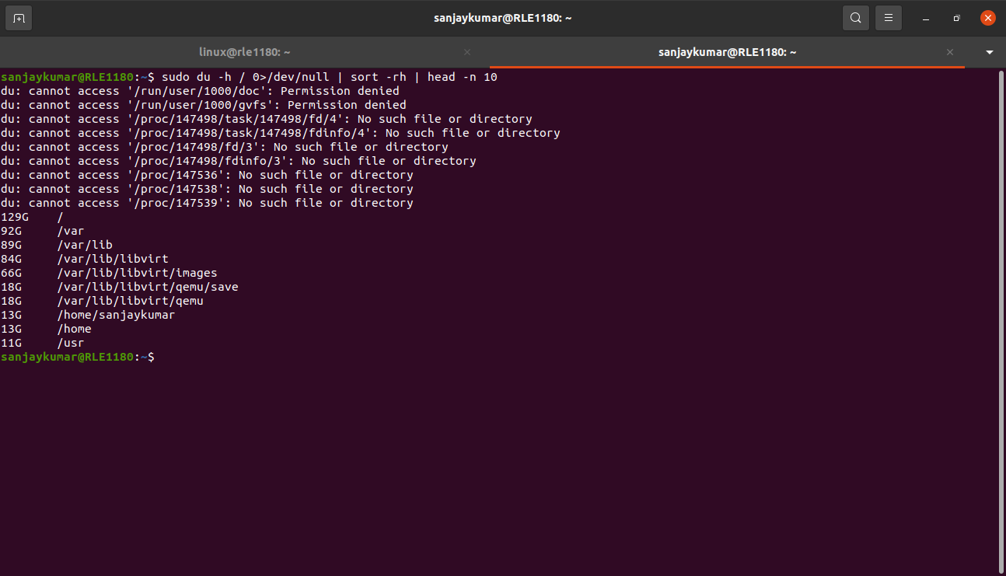

**Part 3: Network Monitoring**

4. **Task:** Monitor network activity using the `iftop` command.

Ex : sudo apt install iftop
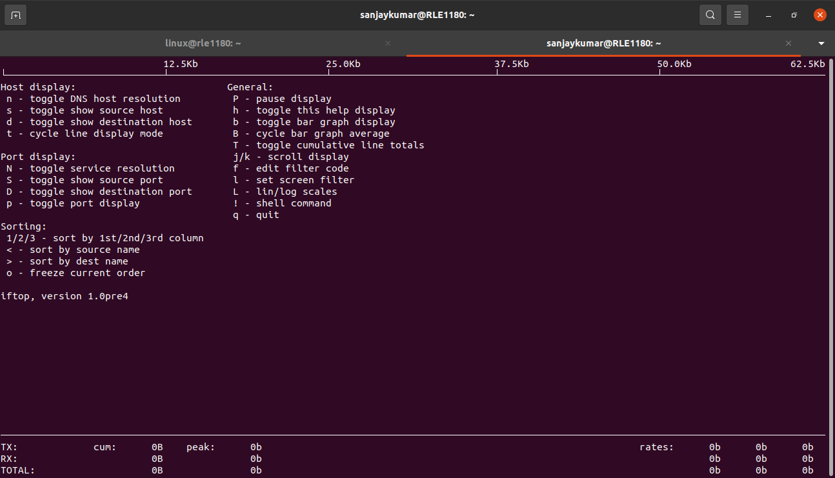
Once iftop is running,it will display real-time network traffic information.
- Interface selection : ‘iftop’ allows you to select a network interface for monitoring. If you have multiple network interfaces, you can choose which one to observe.
- Incoming and outgoing connection : ‘iftop’ displays a list of connections, showing both incoming and outgoing traffic. Each connection is listed with source and destination IP addresses, port numbers, and data transfer rates.
- Display format : by default, ‘iftop’ displays data rates in bits per second (bps), but you can toggle between bits and bytes using the "B" key.
- Sorting : You can sort the list of connections by different criteria, such as total data transfer, source or destination IP, and more.
- Total : ‘iftop’ provides a summary of the total incoming and outgoing data rates.
**Part 4: System Information Gathering**

5. **Task:** Use the `uname`, `lsb_release`, and `hostnamectl` commands to gather system information.

Command 1 : ‘uname -a’

ex : sudo uname -a
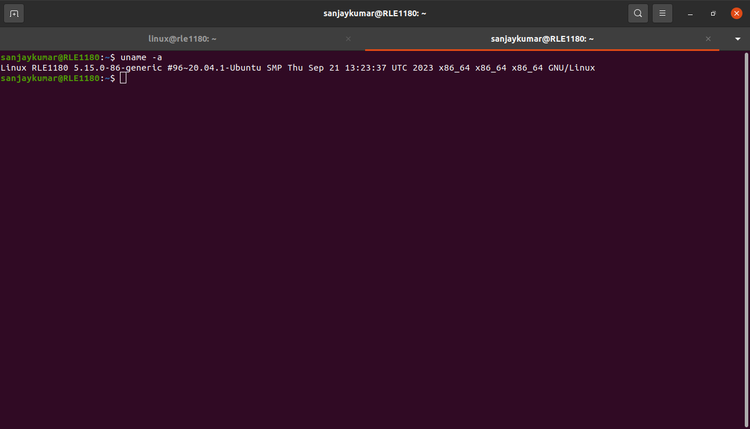
- This command will provide information about the kernel version. For example, the output might look like:

- Linux is the operating system.
- ‘RLE1180’ is the hostname of your system.
- 5.15.0-86-generic is the kernel version
- additional details about the system architecture and OS are also provided.

Command 2 : ‘lsb_release -a’

Ex : sudo lsb_release -a

- This command provides information about the linux distribution. The output will look:
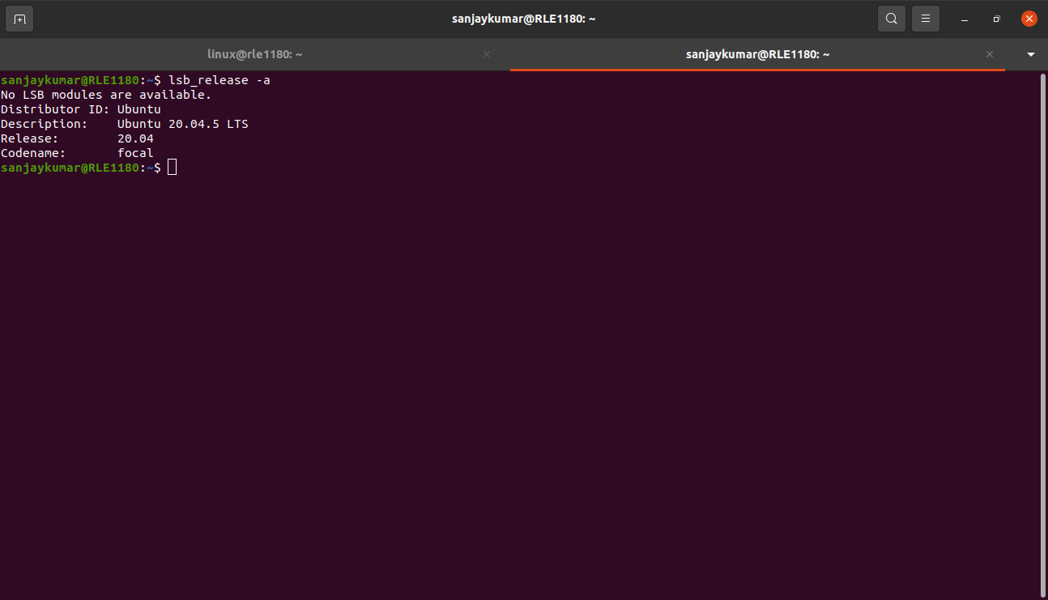
- Distributor ID shows the distribution name (e.g, ubuntu).
- Description provides the distribution's description and version(e.g,ubuntu 20.04.5 LTS).
- Release displays the distribution release version(e.g, 20.04).
- Codename specifies the codename of the release(e.g, focal).

Command 3 : ‘hostnamectl’

Ex : sudo hostnamectl

This command provides information about the hostname and other system information. The output look like:

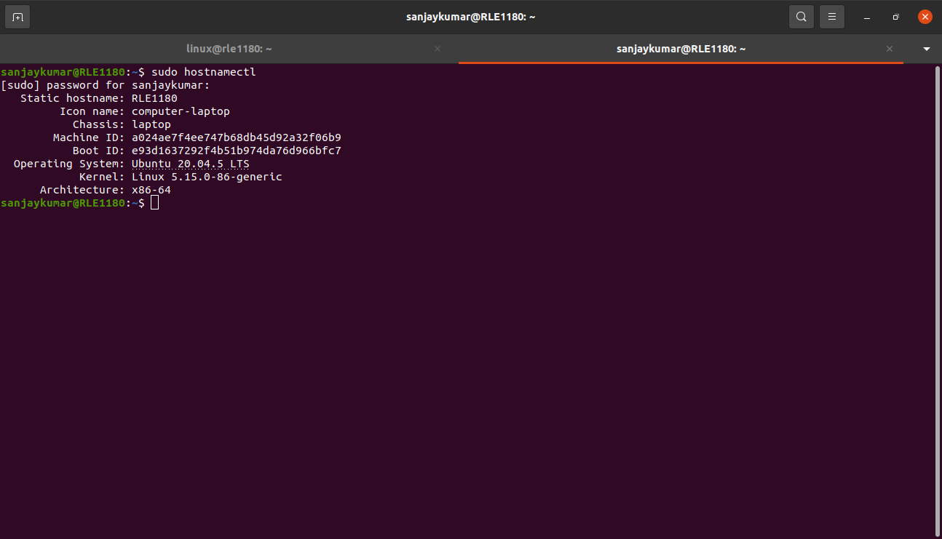
- Static hostname is the hostname of your system.
- Operating system displays the OS name and version.
- Kernel shows the kernel version.
- Architecture provides information about the system architecture.

